Adrian Cuyugan 2014-91450 Stat 266 Test of Goodness of Fit: Komolgorov-Smirnov One Sample Statistic
Problem 4.34 - Ten students take a test and their scores (out of 100) are as follows:  95, 80, 40, 52, 60, 80, 58, 65, 50, 80 | Test the null hypothesis that the cumulative distribution function of the proportion of right answers a student gets on the test is: | $$F_{0}\left(x\right)=\left\{\begin{aligned}0 \\ x^{2}\left(3-2x\right) \\ 1\end{aligned}\right. \begin{matrix}x<0 \\ 0≤x≤1 \\ x>1\end{matrix}$$
$$i$$ | $x$ (ordered) | $$S_{n}(x)$$ | $$F_{0}(x)$$ | $$S_{n}(x)-F_{0}(x)$$ | $$S_{n}(x-ε)-F_{0}(x)$$ | $${|S}_{n}(x)-F_{0}(x)|$$ | $${|S}_{n}(x-ε)-F_{0}(x)|$$ | $$S_{n}(x)-D_{n,α}$$ | $$S_{n}\left(x\right)+D_{n,α}$$
1 | 0.4000 | 0.1000 | 0.3520 | -0.2520 | -0.3520 | 0.2520 | 0.3520 | 0.0000 | 0.5090
2 | 0.5000 | 0.2000 | 0.5000 | -0.3000 | -0.4000 | 0.3000 | 0.4000 | 0.0000 | 0.6090
3 | 0.5200 | 0.3000 | 0.5300 | -0.2300 | -0.3300 | 0.2300 | 0.3300 | 0.0000 | 0.7090
4 | 0.5800 | 0.4000 | 0.6190 | -0.2190 | -0.3190 | 0.2190 | 0.3190 | 0.0000 | 0.8090
5 | 0.6000 | 0.5000 | 0.6480 | -0.1480 | -0.2480 | 0.1480 | 0.2480 | 0.0910 | 0.9090
6 | 0.6500 | 0.6000 | 0.7183 | -0.1183 | -0.2183 | 0.1183 | 0.2183 | 0.1910 | 1.0000
7 | 0.8000 | 0.8000 | 0.8960 | -0.0960 | -0.2960 | 0.0960 | 0.2960 | 0.3910 | 1.0000
8 | 0.8000 | 0.8000 | 0.8960 | -0.0960 | -0.0960 | 0.0960 | 0.0960 | 0.3910 | 1.0000
9 | 0.8200 | 0.9000 | 0.9145 | -0.0145 | -0.1145 | 0.0145 | 0.1145 | 0.4910 | 1.0000
10 | 0.9500 | 1.0000 | 0.9928 | 0.0072 | -0.0928 | 0.0072 | 0.0928 | 0.5910 | 1.0000
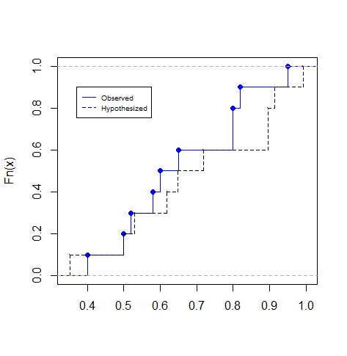 | $H_{0}: F_{x}\left(x\right)=F_{0}\left(x\right)$ for all $x$, $x^{2}\left(3-2x\right)$  $H_{A}: F_{x}(x)≠F_{0}(x)$ for some $x$  To calculate the KS statistic, $D_{n}=\sup_{x}\left|S_{n}\left(x\right)-F_{0}\left(x\right)\right|=\max_{x}{[{|S}_{n}(x)-F_{0}(x)|,{|S}_{n}(x-ε)-F_{0}(x)|]}$ = 0.40  Significance level is set at $α=0.05$. In Table F, the rejection region of $0.05, n=10$ is $D_{n,α}≥0.409$. Since the calculated KS statistic does not exceed of the tabular value, the null hypothesis is not rejected; following a distribution of $x^{2}\left(3-2x\right)$ from the proportion of correct answers a student gets on a test.  P-value method also does not reject the null hypothesis at $0.05$ level of significance:  $$0.05<P\left[D_{n}≥0.40 \right|H_{0}]<0.10$$  The confidence bands are as follows:  $L_{n}\left(x\right)=\max_{ }\left[S_{n}\left(x\right)- D_{n,a},0\right]=0.591$ and $U_{n}\left(x\right)=\min_{ }\left[S_{n}\left(x\right)+ D_{n,a},1\right]=0.509$

Adrian Cuyugan 2014-91450 Stat 266 Test of Goodness of Fit: Komolgorov-Smirnov One Sample Statistic
ks.observed <- c(0.40, 0.50, 0.52, 0.58, 0.60, 0.65, 0.80, 0.80, 0.82, 0.95)
ks.hypothesized <- (ks.observed^2)*(3-2*ks.observed) #x^2(3-2x)
ks.df <- cbind.data.frame(ks.observed, ks.hypothesized) # Combines two vectors in a dataframe format
ks.df # Views the dataset
## ks.observed ks.hypothesized
## 1 0.40 0.352000
## 2 0.50 0.500000
## 3 0.52 0.529984
## 4 0.58 0.618976
## 5 0.60 0.648000
## 6 0.65 0.718250
## 7 0.80 0.896000
## 8 0.80 0.896000
## 9 0.82 0.914464
## 10 0.95 0.992750
# Plots the empirical cumulative distribution
plot(ecdf(ks.observed), pch = 19, verticals = T,col='blue', main = NULL, xlab = '')
lines(ecdf(ks.hypothesized), verticals = T, pch = 46, lty = 2)
legend(x = 0.37, y = 0.9, legend=c("Observed", "Hypothesized"),
lty = c(1,2), col = c('blue', 'black'), cex = 0.6)
# Runs KS test using two-sample but the other population is based on the hypothesized distribution
ks.test(x = ks.observed, y = ks.hypothesized)
## Warning in ks.test(x = ks.observed, y = ks.hypothesized): cannot compute
## exact p-value with ties
##
## Two-sample Kolmogorov-Smirnov test
##
## data: ks.observed and ks.hypothesized
## D = 0.3, p-value = 0.7591
## alternative hypothesis: two-sided

